Laybacks 2021 Seven Mile Beach family and partners holiday

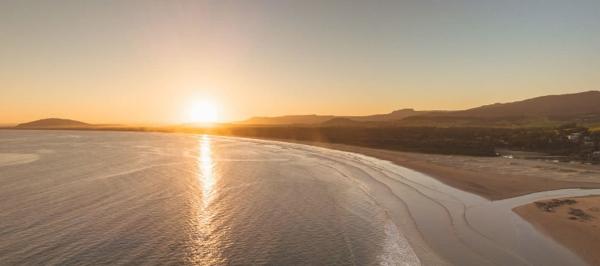
Hi Laybackers
Well 2020 was definitely not the year for club activites and adventrues. So to get 2021 off to a good start, the Laybacks socail committee has organised a family and parnters trip to seven mile caravan park on the 12-14th March.
That’s right, 2 laybacks camping trips YEAH!!!
We’ll still keep the classic winter aTabourie trip, and Seven Mile will be the end of summer trip, with the aim of getting the families and partners to all catch up together, create stories and just have a load of fun together.
Seven mile beach is a pitchuresque campground. It offers great longboarding waves for people of all abilities, mums included! We could even get a mums/ladies heat going if the waves permit!
The park is right next to the beach and has great facilities (including a pool). There is a café nearby, and the Fisho’s club just up the road if you don’t feel like cooking. If you want to go for a drive Gerringong shops are a minutes drive away.
If you would like to come, bookings will need to be made ASAP. The caravan park does not take group bookings, so it will be upto individual members to make their own bookings. We have chosen a date that has a good amound of accomodation availability still.
Covid has really made caravan parks popular and they book out much earlier than they traditionally would. So if you want to come, make a decision, call up and book your spot. The following week is already half booked up!
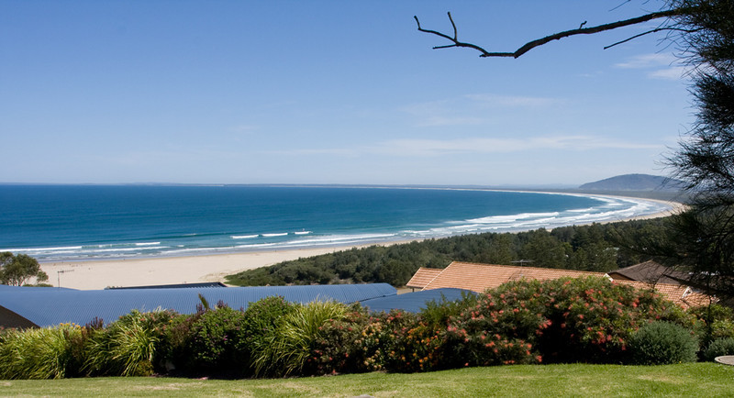
Accomodation options include;
- camping
- beach shacks (there are all 8 of these available currently, and are a great option)
- and there are currently 2 deluxe cabins available.
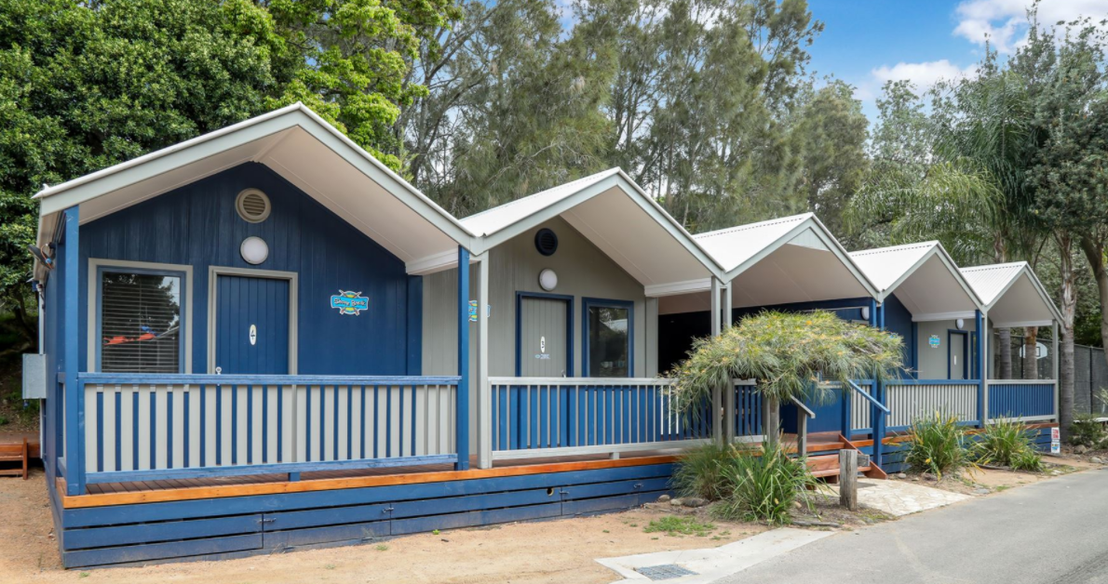 | 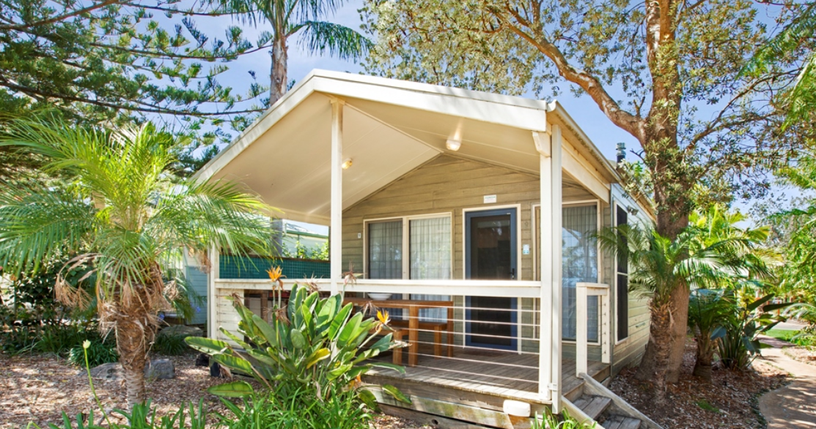
Beach shacks | Cabins

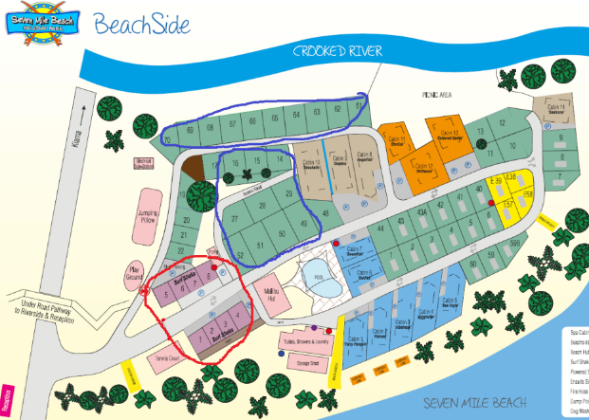
Attached is a map of the campground to see where we are suggesting everyone book.
There are 8 beach shacks being reserved for one week for any interested members to book. Its first in best dressed.

Booking details ; weekend 13th march 2020
Seven mile beach caravan park contact number; 4234 1340
Website; https://www.kiamacoast.com.au/seven-mile-beach-holiday-park/

Any questions call or email
Janne – 0423406483, janne.schwarck@gmail.com
Kelly – 0423577525, Kelly@strongerathletics.com.au

Again if you would like to come, we recommend making your booking ASAP.

We are looking forward to everyone having a great time together!

Kind regards,
The Laybacks Social Committee.

